Fire Safety Logbook

Name of Company:

Address:

Responsible Person(s):

Tel:

Table of Contents

Section 1. Introduction to the Law & the Fire Safety Logbook

Section 2. Schedule of Mandatory Responsibilities

Section 3. Useful Contacts (Client editing)

Section 4. List of Duty Holders & Fire Wardens (Client editing)

Section 5. Fire Safety Training & Drills

Fire Safety Training Record (Client editing)

Section 6. Fire Alarm & Detection System

Section 6A. Other Devices Activated by the Fire Alarm System

Fire Alarm - Record of Tests (Client editing)

Section 7. Emergency & Escape Lighting

Emergency & Escape Lighting – Record of Tests (Client editing)

Section 8. Fire Fighting Equipment – Hose Reels

Section 8A. Fire Fighting Equipment – Portable Extinguishers

Hose Reels & Portable Extinguishers – Record of Tests (Client editing)

Section 9. Miscellaneous Tests & Checks

Miscellaneous Tests & Checks Record (Client editing)

Section 10. Visits by the Fire & Rescue Service

Fire & Rescue Service – Record of Visits (Client editing)

Section 1. Introduction to the Law & the Fire Safety Logbook

The Regulatory Reform (Fire Safety) Order 2005 requires that every workplace premises must have a nominated Responsible Person, this is normally the Owner / Occupier or Leaseholder, (in Private Members Clubs it is invariably the Secretary of the organisation).

The Responsible Person of an organisation or workplace is to ensure a Fire Safety Policy and an effective Emergency Plan is in place. Where 2 or more Responsible Persons share a single occupancy or group of premises, relevant safety information sharing and a co-operation of mutual understanding is to be put in place.

The Responsible Person must ensure all fire safety systems; equipment and devices are maintained in efficient working order and in good repair. Additionally, where there are employees, (including contracted undertakings and volunteers), they should be provided with adequate safety training. The Order requires that any fire safety system tests, maintenance and fire safety related training records are valid and audited to ensure they are being carried out to demonstrate a robust fire safety management culture.

The Responsible Person should appoint Duty Holders to have sufficient authority and influence within the organisation to carry out in-house routine fire safety tasks, daily management of fire safety including control of visitors, the public and contractors and end-user testing of fire safety systems. The Responsible Person should also, (where necessary), appoint sufficient nominated Fire Wardens to assist in emergency evacuation, (including those with disabilities or mobility impairments), check rooms, floors and areas are clear of staff, fire doors are closed and any hazardous machinery or processes are stopped in a fire situation and attempt to fight a fire only if it is safe to do so.

The Responsible Person should ensure that skilled Competent Persons are engaged to carry out specific tasks, i.e. fire risk assessments, fire safety training, routine servicing and maintenance of fire safety systems and fire fighting equipment, suitably qualified electrical and gas engineers to carry out routine servicing, maintenance and repairs. Any contractors carrying out structural works (that require an element of fire resisting materials incorporated into the process) should have the recognised industry skills and experience to do so and that only suitably fire-rated & certificated materials are sourced.

This fire safety logbook has been prepared to assist the Responsible Person in co-ordinating and maintaining an ‘evidence based’ fire safety record keeping and audit system. It is recommended that this logbook be kept in a loose-leaf format with new record keeping pages being photocopied or downloaded when required. Should you require an electronic copy please contact us at www.peninsulafireconsultants.co.uk

The logbook should be kept up to date and readily available for inspection, or audit, by the Fire and Rescue Service or any other Enforcing Authority, as and when it is required.

Where the logbook refers to a specific method of testing a technical element of your fire safety systems by the end-user, (weekly tests of fire alarm, monthly emergency lighting or routine recognition of system faults etc.), they should seek the guidance of a Competent Person to instruct and mentor the necessary training and skills to undertake the task. Remember that the only ‘foolish’ question about safety is one that is not asked.

Note: It may be considered an offence for any person to knowingly make a false entry, (or deliberately withhold any fire safety related information from being entered), in this logbook under Articles 8, 11, 15, 17, 21 & 38 of the Regulatory Reform (Fire Safety) Order 2005.
Section 2. Schedule of Mandatory Responsibilities

Routine Safety Checks | Scheduled Task
Fire hazards & flammable materials | All fire hazards are to be identified, eliminated or controlled. Flammable materials to be stored in such a manner that they do not present an unnecessary hazard, kept to a minimum & well away from ignition sources. All electrical equipment is to be tested in accordance with mandatory legislation, both mains circuits & portable equipment
Means of escape | Means of escape corridors, including final exits are to be free of obstruction & flammable materials & available for use during times of occupation. Doors should be maintained & designated fire doors kept closed. Electrically operated doors to be provided with emergency opening devices, that ‘default to open’ when the mains power circuits fail & open towards the direction of escape. Stairs, (including external escape stairs), are to be free of obstructions, in good order with non slip surfaces & adequately maintained
Locks & fastenings | All doors through which persons have to pass to evacuate the premises, should be readily available at all material times of occupation, without the use of a key & equipped with a single action opening device
Emergency & escape lighting | Where installed, the emergency & escape lighting is to be in good working order, tested & maintained in accordance with the industry approved code of practice
Signs & notices | All fire safety signs and notices should be kept visible and permanently fixed in place
Fire warning systems | Where installed, fire detection & alarm systems should be in good working order & maintained in accordance with the industry approved code of practice. Test fire alarms weekly to ensure they function correctly & can be heard throughout the premises & ensure the system is maintained in accordance with the industry approved code of practice
Fire fighting equipment including fixed installations | All fire fighting equipment is to be readily available, unobstructed and maintained in accordance with the industry code of practice
Disabled (or elderly infirm) persons | Disabled employees, residents & visitors are to be afforded special arrangements to assure their safety on the premises at all times in event of a fire or other emergency
Furniture and equipment | All furniture items to meet current mandatory regulations for flammability & placed in such a manner as to not impede the means of escape
Fire Risk Assessment, (FRA), fire safety records, staff training & emergency plan | The FRA, all fire safety related records, staff training & emergency plan procedures are to be kept up to date, reviewed at least annually & to be reactive to situations as they occur. They are also to be made available for inspection by any Regulatory Authority or Authorised Person in the execution of his or her duty, without exception

Section 3. Useful Contact Details (In a fire or emergency dial 999)

Fire alarm  (& suppression system where present)  servicing maintenance & repairs. |  | Emergency & escape lighting maintenance and repairs.
Fire fighting equipment servicing maintenance & repairs. |  | Building maintenance (fire doors, fire resisting materials signs & notices etc.)
Environmental & Health & Safety Agency |  | Electrical installation servicing maintenance & repairs
Gas installation servicing & maintenance & repairs |  | Fuel /heating oil supplier, servicing maintenance & repairs
Fire & Rescue Service Community & Business Helpline (Mon to Fri office hours) |  | Fire Risk Management Consultants  (Fire Risk Assessments etc.)
Other: |  | Other:
Other: |  | Other:
Other: |  | Other:
Other: |  | Other:
Other: |  | Other:
Other: |  | Other:

Section 4. List Of Duty Holders & Fire Wardens

Position  (Duty Holder / Fire Warden) | Name | Department | Contact No.

Section 5. Fire Safety Training & Drills

Fire safety training must be given to employees so that they are aware of;

- What to do if they discover a fire
- How to raise the alarm in the event of a fire.
- What to do if they hear the fire alarm
- Where fire extinguishers are located and how to use them (if it safe to do so)
- All the escape routes from the building
- The whereabouts of the evacuation assembly point(s)
- How to call the Fire and Rescue Service
- Arrangements are in place for the evacuation of people with special needs
- The dangers associated with obstruction of fire exits and wedging open of fire doors

Fire safety training should be delivered;

- At the time staff are initially employed or soon after
- To staff with specific tasks in the event of a fire, (Fire Warden)
- To staff being exposed to new or increased risks, and;
- At periodic intervals, (at least annually, depending upon the nature of the risk)

Fire safety evacuation drills - requirement and goals;

- Undertaken at periodic intervals appropriate to the nature of the risk, (a minimum of one safety drill each year is recommended, more frequent with high turnover or seasonal hiring of staff)
- All employees (including visitors etc.) MUST evacuate the premises and make their way to the established Assembly Point(s) regardless of seniority or commitments

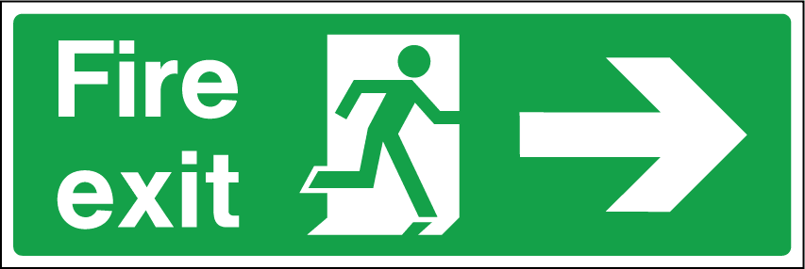 | 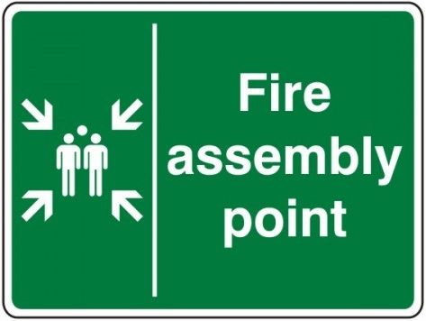 | 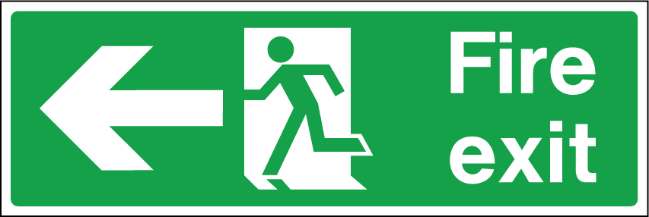

- Drills are carried out to ensure employees know what to do in the event of fire
- Employees know where the building’s alternative exits are (if applicable)
- All staff can be accounted for, including visitors, the public and contractors
- Nominated person(s) are in a pre-determined location to await the arrival of the Fire & Rescue Service and other emergency services for exchange of information

Training for staff with ‘enhanced roles’ delivered to;

- Duty Holders - fire safety system & equipment testing & maintenance person(s)
- Fire wardens and those responsible for isolating hazardous machinery and areas
- Nominated persons to assist with disabled evacuation, (safe handling etc.)
- Nominated persons to tackle a fire in the workplace and those engaged in ‘Hot Work’ processes or working with flammable, oxidising and or explosive processes

Fire Safety Training Record

Name | Date of appointment | Type of training / evacuation or drill | Date | Name of trainer

Fire Safety Training Record

Name | Date of appointment | Type of training / evacuation or drill | Date | Name of trainer

Section 6. Fire Alarm & Detection System

Fire alarm testing, servicing and maintenance should be carried out in accordance with the manufacturer’s instructions and current British Standard 5839 Part 1.

It is important that any testing of the fire alarm should not result in a false signal of fire being transmitted to a remote receiving station or the Fire & Rescue Service

Daily Checks By End User - Inspect the main fire alarm panel for normal operation of the system, noting any faults in the logbook when they occur and contact the system maintainer for remedial action. Where provided, check that the connection to any remote monitoring centre is functioning and the Zone Plan(s) is legible, accurate (reflects the actual building floor plans) and; is displayed near the alarm panel where it can be interrogated by the Fire & Rescue Service. Note: There is no requirement to record daily checks if no faults are present.

Weekly Test By End User – Carry out a function test to ensure that the system is capable of operating under alarm conditions by the following method;

Operate a fire alarm call point (coloured red) at approximately the same time and day each week using a different call point for each successive weekly test. Where appropriate inform the remote monitoring centre prior to; and after the test. Automatic self-closing fire doors, ‘Doorguard’© devices, roller shutters, interfaced passenger lifts and some other peripheral devices should also be subjected to weekly tests (see next page for further details of interfaced peripheral system and device testing, servicing and maintenance frequencies).

Periodic inspections Servicing & Maintenance - Carried out by a competent person, e.g. a fire alarm engineer. Requirements for these inspections and tests will depend upon the type and design of the system but should generally be carried out at six monthly intervals and in accordance with the current British Standard as detailed below;

Smoke & Heat Detectors & Main Fire Alarm Panel

- Carry out a regular visual inspection of each detector to check for damage, excessive accumulations of dirt, heavy deposits of paint, obstruction with storage materials and other conditions likely to interfere with correct operation.

- Each detector should be checked and tested for correct operation and sensitivity by a competent fire alarm engineer (see periodic inspections & tests above) in accordance with the manufacturer’s instructions and the current British Standard.

- DC battery cells in fire alarm panels (and individual DC battery cells in detectors / amplifiers of wireless systems) to be analysed and replaced where necessary

Measures To Reduce Unwanted Alarms
False alarms will not only disrupt business operations but may also result in a monetary fine imposed on the Responsible Person(s) by the Fire Authority should repetitive deployment of Fire and Rescue Service resources be despatched to your premises answering spurious non-emergency alarms when they could be attending incidents where life or property is in danger. To reduce the probability of false alarms on systems incorporating automatic fire detectors it is important that a suitable regime of testing and maintenance is in place. The cause of any false alarm should be properly investigated with measures being taken to avoid a repetition.

Section 6A. Other Devices Activated By The Fire Alarm System

Fire Resisting Door Hold-Open Devices – Wall or floor mounted devices that release the open fire door to its closed position upon activation of the fire alarm. Note some devices are independent of the fire alarm system, ‘Doorguard’© for example is an acoustic device fitted to the bottom of the fire door and will release the door when the sounders operate. These devices require a separate regular battery replacement regime to ensure reliability.

Emergency Door Release Devices – These devices are provided for normal daily security to control access to buildings (coloured green), they should also be tested weekly to ensure they are functioning correctly and the door is available for emergency use and other doors for example; automatic revolving or sliding access and egress doors, should move freely without a powered supply when the fire alarm system operates

Fire Resisting Roller Shutters – Normally fitted to isolate openings in ‘high risk’ areas, kitchen-serving hatches etc. or to protect the means of escape.

Fire & Smoke Dampers – These devices may be fitted integrally within the building’s ventilation systems where the passage of fire and smoke can be prevented and controlled within the trunking that passes through fire resisting construction or compartments. If they are electronically operated, there will be an indication at the main fire alarm panel but you must ensure that they have ‘re-set’ to normal ventilation status after the test. (Note: Fire & smoke dampers operated by ‘fusible link’ are not subjected to a regular test regime)

Fire & Smoke Control Vents – These devices may be fitted to the roof structure, within protected corridors and escape stair routes (in high rise buildings) or extraction hoods above commercial deep fat fryers and operate automatically with the fire alarm to ensure that the products of combustion and toxic smoke are extracted from the building and escape routes remain tenable for persons evacuating the premises. They will also be an integral design element within gaseous suppression systems (see note below)

Fire Suppression Systems – Hazardous processes (Life Protection Category) or ‘commercially high value’ (Property Protection Category) requirements may be provided with automatic fire suppression. These systems can be water spray, water mist or inert gas (Nitrogen or Carbon Dioxide for example). These systems are designed to be automatic, operate upon detection of a fire and have a back-up manual facility. Gaseous systems must give sufficient warning and time delay to allow escape for the occupants of an area or compartment before the gas is released and; have the capability to mechanically extract the gas and products of toxic smoke from the area or compartment after operation, (normally operated and maintained only by competent trained persons within the organisation or the Fire & Rescue Service)

Electricity, Gas & Fuel Emergency Shut Off - These devices are normally fitted to the buildings’ electrical supply outlet to specific hazardous areas or to gas or fuel supply valves and designed to operate manually (push button) or when the fire alarm activates and automatically isolate the supply of electricity, gas or fuel in the event of a fire

Passenger lifts – Some passenger lifts will interface with the fire warning system to prevent people from using them in an emergency, if this type is installed in your building, ensure that upon activation of the fire alarm, the lift car defaults to the ground floor, the doors remain open and the call buttons will not operate when the fire alarm is sounding.

Note: All checks, (not daily, unless fault is present) tests and maintenance including faults and any remedial action taken, should be entered in the logbook. The date on which any fault is rectified is also to be recorded.

Examples of Devices & Systems - The images below are typical examples of devices or systems that may be interfaced with the fire alarm system, the testing, servicing & maintenance skills will range from ‘Competent’ to ‘Specialist’.

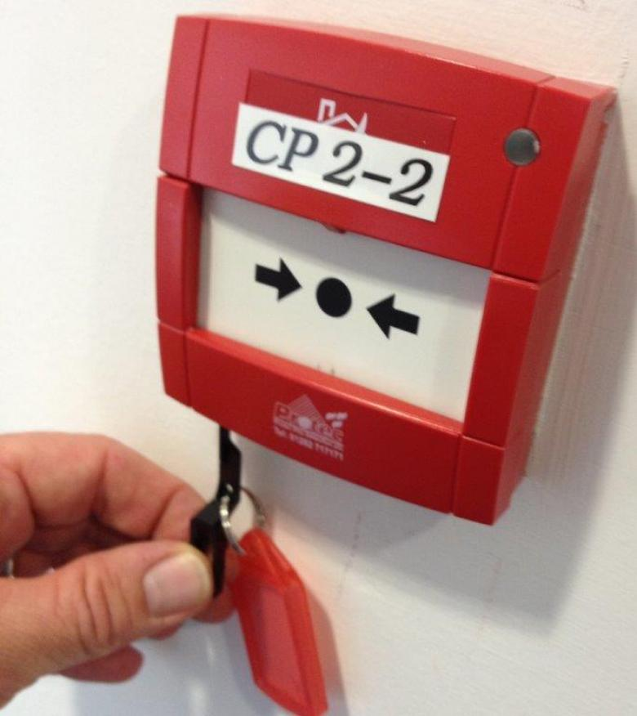 | 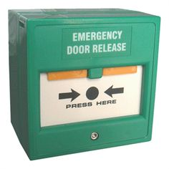 | 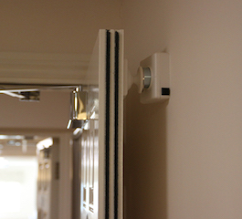 | 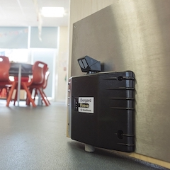
Call point & test key | Emergency door release | Fire door ‘hold-open’ device | ‘Doorguard’© device
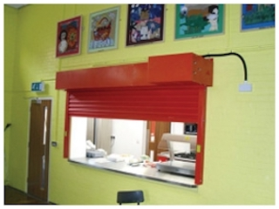 | 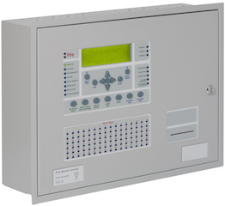 | 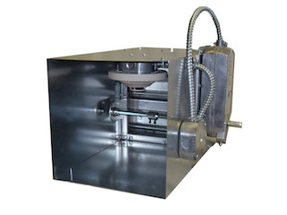 | 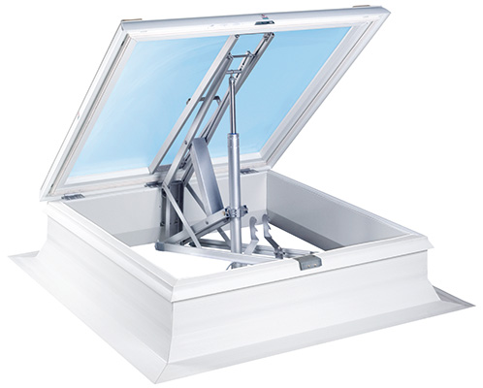
Fire resisting roller shutter | Fire alarm panel | Ventilation system fire damper | Roof smoke vent
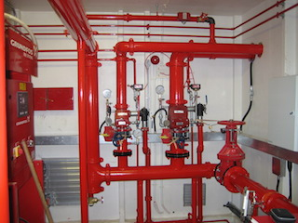 | 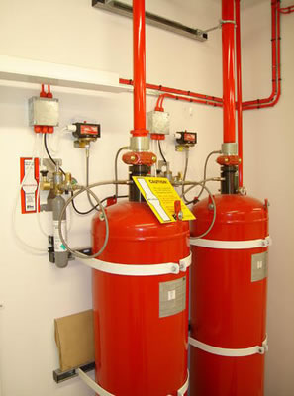 | 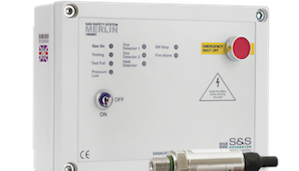 | 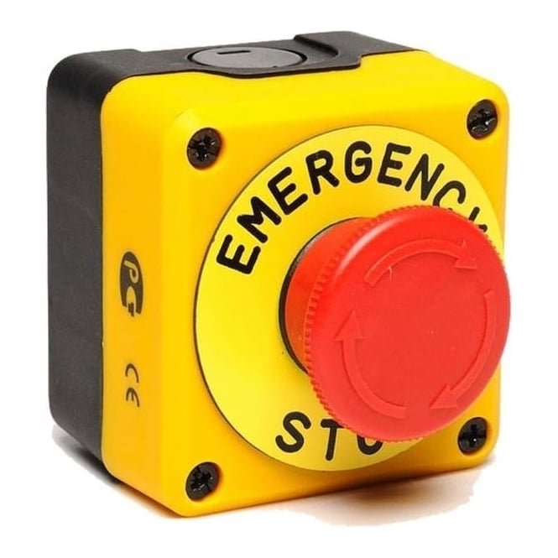
Water sprinkler plant | Gas suppression system | Automatic gas supply isolator | Manual gas/electric stop

Testing Frequency – Fire alarm interfaced devices and systems are to be tested at a frequency in accordance with the relevant British Standard, Approved Code of Practice and the manufacturers specified instructions. Manual call points, emergency door releases, roller shutters and emergency stop devices should be tested weekly for example, whereas other more technical devices and systems, (wet sprinkler and gaseous suppression systems, fire dampers and roof vents etc.), will more likely be subject to a separate testing, servicing and maintenance regime, normally supported by a ‘contractual arrangement’ with a ‘specialist’ competent person or company. All evidence of testing, servicing and maintenance however, must be recorded; and this information is to be collated and kept with the other records with this logbook.

Fire Alarm, (automatic door release & other devices) - Record of Tests

Date | Fire alarm call point/ detector location or number | Automatic door release(s) & other devices (list type) | Remedial action required | Date completed |  | Name of tester (print)

Fire Alarm, (automatic door release & other devices) - Record of Tests

Date | Fire alarm call point/ detector location or number | Automatic door release(s) & other devices (list type) | Remedial action required | Date completed |  | Name of tester (print)

Section 7. Emergency & Escape Lighting

The purpose of emergency and escape lighting is to illuminate safe travel routes within a building in an emergency should the primary lighting circuits fail. The safe route is considered to be not just the buildings’ interior rooms, stairs and corridors to the final exit doors, but also the external routes, illuminating exit door thresholds, flat roof escape routes, external escape stairs and landings, external pathways, any obstacles and hazards along the escape routes; and ultimately, the Assembly Point area(s). The provision, testing servicing and maintenance of emergency and escape lighting is to be carried out in accordance with the manufacturer’s instructions and current British Standard 5266 Part 1.

Other areas, apart from escape routes, may also require emergency lighting in the event of failure of the primary lighting circuit, fire alarm panel and zone plan location, fire fighting equipment, first aid stations, emergency valves, switches and hazardous machinery isolating devices and disabled Refuge Areas (e.g. voice communication equipment).

The emergency and escape lighting installation will be one of two, (or a combination of both) categories, Non-Maintained (not permanently illuminated, function upon failure of the lighting circuit) and Maintained (permanently illuminated) provided in windowless rooms, stairs and corridors, basements, underground car parks, theatres and cinemas

Emergency and escape lighting tests, servicing and maintenance should be carried out in accordance with the manufacturer’s instructions and current British Standard 5266 Part 1.

Daily – Carry out a visual inspection of each luminaire’s integral LED (red or green light) that indicates a healthy AC supply and DC battery health. Note: There is no requirement to record daily checks if no faults are present.

Monthly – Look for any obvious signs of damage or deterioration, including the cleanliness and general condition of lenses and diffusers. Simulate a failure of the normal lighting supply (e.g. operate the ‘test switch’ or isolate the primary lighting circuit under controlled safe conditions) for sufficient time to allow all luminaires in the system to be checked for correct operation.

Annually – Competent engineer to simulate a failure of the normal lighting supply for the full duration of the battery (normally 3 hours) and carry out a test of the charging arrangements to ensure efficient recharging function and battery capacity health checks.

Note: All checks, (not daily, unless fault is present), tests and maintenance including faults and any remedial action taken, should be entered in the logbook. Dates on which any fault is rectified is to be recorded

Examples of Emergency & Escape Lighting, Test Switch & Key;

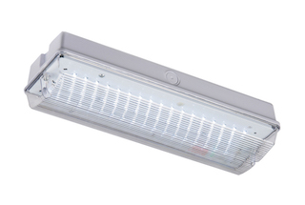 | 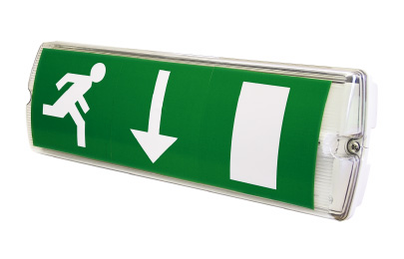 | 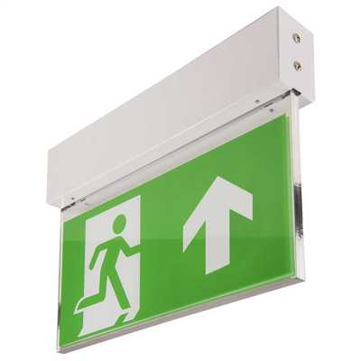 | 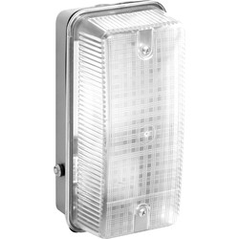 | 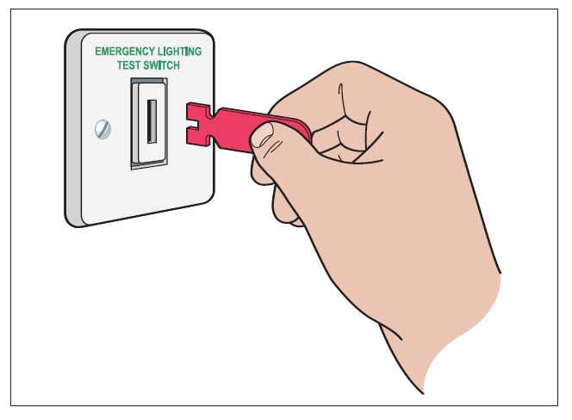
Emergency lighting | Directional escape lighting | Pendant lighting | External lighting | Test switch & key

Emergency & Escape Lighting - Record of Tests

Date | Type of test | Remedial Action Required | Date completed | Name of tester  (print)

Emergency & Escape Lighting – Record of Tests

Date | Type of test | Remedial Action Required | Date completed | Name of tester  (print)

Section 8. Fire Fighting Equipment - Hose Reels

Hose reel testing, servicing and maintenance should be carried out in accordance with the manufacturer’s instructions and the current British Standard 5306 Part 1

Hose Reels are provided in premises where there is a risk that a sustained first attack fire fighting is necessary beyond that of a fire extinguisher (typically factories or warehouses with large floor areas and combustible storage etc.). It should be noted that as well as a competency of training in its operation above that of fire extinguishers, the use of a hose reel in an emergency will invariably breach fire resisting doors along the route where it is deployed via means of escape corridors at its full length. Also the longer term servicing and maintenance schedules are more onerous and costly than portable fire extinguishers, with the requirements of Health & Safety ‘Legionella’ testing and monitoring.

Hose Reel Types - Some hose reels are fixed as a protrusion from the wall and others can be recessed in cabinets. Some hose reels are automatic in operation when they are pulled off the central housing drum and the inertia opens the supply valve to produce water at the nozzle. Other types require the ‘user’ to operate a manual valve at the hose reel supply pipe to charge the hose with water before deployment. Note: Both automatic and manual types will require the discharge valve to be operated at the nozzle outlet.

Alternative Provision – (Advisory) Where hose reels are a ‘legacy’ provision in lower risk premises, (office blocks for example), it may be beneficial to consider substituting this provision with a more cost effective solution of sufficient wall mounted water extinguishers, although a full ‘impact’ risk assessment is necessary before any hose reels are removed.

Daily – Check that the equipment appears satisfactory, is not leaking and the hose is ready for use, (e.g. not tangled or rolled up haphazardly on the drum). Note: There is no requirement to record daily checks if no faults are present.

Annually – Check the operating instructions are correct (manual or automatic operation) and clearly displayed on the hose reel or nearby on an adjacent surface. Each hose reel should be completely run out to its full length and subjected to the optimum operational water supply pressure to ensure the hose is in good condition and that all couplings have integral seals and are watertight.

Note: All checks, (not daily, unless fault is present), tests and maintenance including faults and remedial action taken, should be recorded. The date each fault is rectified should also be recorded.
Examples of a Hose Reel and Relevant Notices;

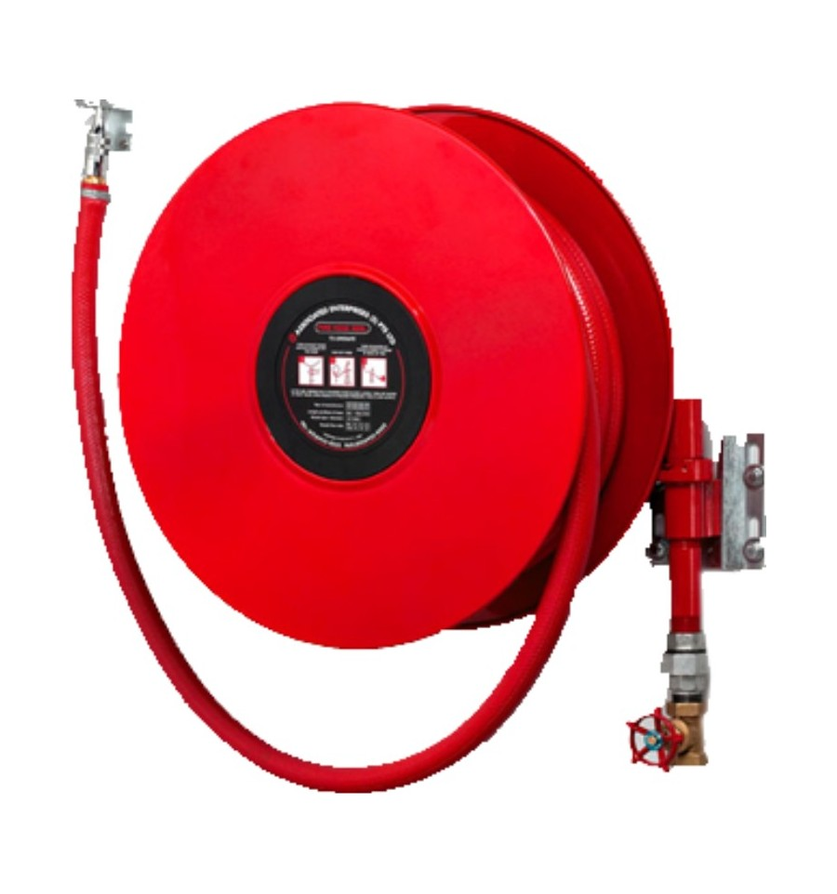 | 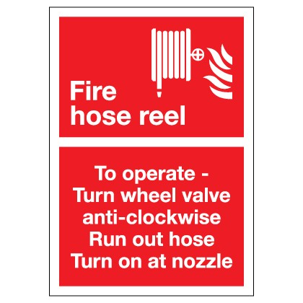 | 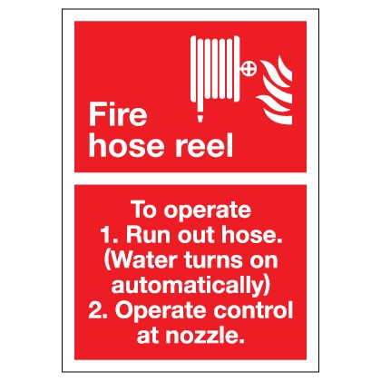
Typical wall mounted hose reel | Manual instructions | Automatic instructions

Section 8A. Fire Fighting Equipment - Portable Extinguishers

Portable fire extinguisher testing, servicing and maintenance should be carried out in accordance with the manufacturer’s instructions and current British Standard 5306 Part 8.

Daily Visual Checks - Check all extinguishers are in place and pressure indicators, where fitted, indicate the equipment is serviceable (e.g. needle is within the ‘green zone’ of the pressure gauge). Fire blankets are in place (sited normally in kitchens) and appear not to have been used or taken out of the container. Note: There is no requirement to record daily checks if no faults are present.

Monthly - Check to ensure each extinguisher is in position, accessible, not discharged, damaged, or has lost pressure (if fitted with a pressure indicator) and that the operating instructions are clear, legible and facing outwards. The discharge tube and nozzle apparatus is in good condition and any tamper-proof seal is in place. Ensure that extinguisher locations (fire points) are provided with clear signage indicating the type of and the use (what type or classification of fire) the equipment is designed for. If replacement stock is held, these units are also subject to the monthly test. Note: Externally sited extinguishers that are susceptible to theft or damage, should be more frequently accounted for and checked.

Annually - Portable fire fighting equipment should be inspected by a competent person, in accordance with the manufacturer’s instructions and the current British Standard. Where circumstances require, e.g. where extinguishers are sited in exposed external locations, they are best sited in a cabinet or other enclosure and depending upon seasonal weather conditions, an element of anti-freeze may also need to be added to the extinguisher contents, this should be done following the recommended manufacturers instructions. If replacement stock is held, these units are also subject to the annual test.

Note: All checks, (not daily, unless fault is present), tests and maintenance including faults and remedial action taken, should be recorded. The date on which each fault is rectified should also be recorded.

Examples of Extinguishers, Signage, Pressure Gauge & Tamper-Proof Seal

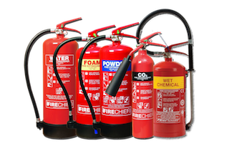 | 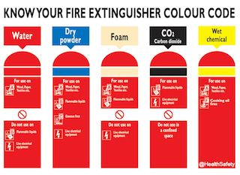 | 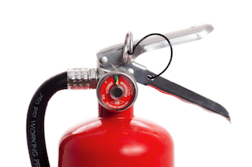
Typical types of extinguishers | Colour code notices for fire points | Pressure gauge & Tamper-proof seal

Hose Reels & Portable Extinguishers - Record of Tests

Date | Hose Reel or Extinguisher & location | Inspection or test  Annually or Monthly | Remedial action required | Date completed | Name of tester  (print)

Hose Reels & Portable Extinguishers - Record of Tests

Date | Hose Reel or Extinguisher & location | Inspection or test  Annually or Monthly | Remedial action required | Date completed | Name of tester  (print)

Section 9. Miscellaneous Tests & Checks

A good housekeeping regime is the best method of maintaining a safe environment in the workplace. Routine disposal of waste materials will also reduce any unnecessary ‘fire loading’ within the premises. The means of escape, together with the measures provided for the protection of the means of escape, should be inspected at periodic intervals., protection measures are described as ‘Passive’ and ‘Active’ (Passive measures are the fire resisting construction including the fire doors, Active measures are the fire warning, emergency lighting and any other interfaced emergency systems). The ‘Miscellaneous Checks’ should ensure all internal and external exit routes are unobstructed and that exit door furniture (panic bars etc.) and fire resisting door self-closing devices operate efficiently. Additionally, fire resisting doors and partitions should be in satisfactory repair and all the relevant Fire and Health & Safety signs and notices are legible, instructions are valid and properly displayed.

Daily Checks – Check all emergency exit doors are not locked or obstructed and are available for use at all times that the premises are occupied. Fire resisting doors are not wedged open (not applicable to those doors that are held open by specific devices connected to the fire alarm). Ensure voice communication equipment (emergency phones etc.) sited at Refuge Points are serviceable. Emergency escape routes and stairs are kept free of obstructions. Heating appliances are kept clear of flammable materials and clothing. Flammable materials used safely, kept clear of ignition sources, not allowed to accumulate unnecessarily in the workplace and returned to safe storage after use. Note: There is no requirement to record daily checks if no faults are present

External waste is adequately managed with secure lockable recycling bins awaiting collection and kept away from external windows and doors to discourage the opportunity for arson. End of business shutdown procedures are carried out to ensure any non-essential electrical equipment is isolated and other hazardous processes made safe.

Monthly Checks – Ensure all internal fire resisting doors and emergency exit doors are functional, not damaged, self-closers are capable of free movement and assist the door to close fully into the frame, intumescent and cold smoke seals on the fire resisting door edges are in place and not damaged and that there are no excessive gaps (over 3 mm) between the fire resisting door and frame when closed, also between any double door meeting faces. Relevant notices are displayed on fire doors, (e.g. ‘Fire Door Keep Closed’, ‘Plant Room Keep Locked Shut’ etc.) and general fire safety notices (e.g. ‘Action in the Event of Fire’ and ‘Do Not Use Lift In Event of Fire’ etc.) and directional escape signs are prominently displayed throughout the premises escape routes. Inspect external escape stairs and routes to confirm they are kept free from growth of algae and moss by regular cleaning. Check the condition of metal or timber fabricated stairs, handrails, landings and walkways are recorded, with remedial action taken where deterioration or damage is noted. Additional ‘seasonal’ reactionary measures may be required during colder periods to ensure adequate salting and/or gritting of external stairs and walkways and access routes from the premises to the Assembly Point, is carried out during freezing conditions to avoid slip, trip and fall injuries to persons escaping in an emergency.

Note: All checks, (not daily, unless fault is present), tests and maintenance including faults and remedial action taken, should be recorded. The date on which each fault is rectified should also be recorded

Examples of Miscellaneous Checks & Hazard Recognition - The following images serve as examples of fire safety related items and hazards to check for, your premises may have different devices and any hazards may be unique to your work processes.

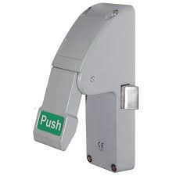 | 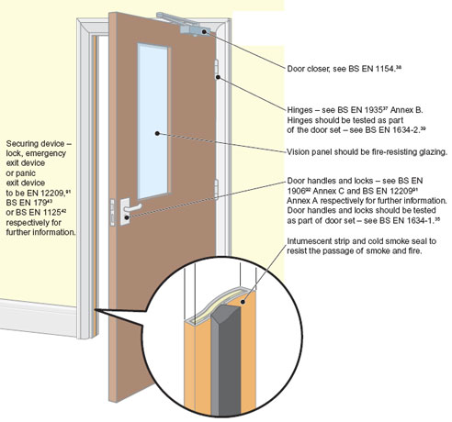 | 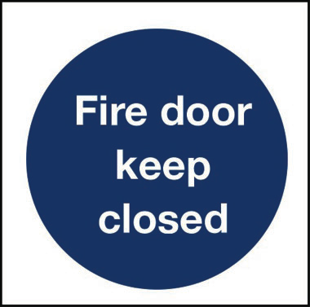
Check emergency exit door devices are serviceable | Fire resisting doors, closers, seals, furniture & gazing appear in good condition | Fire doors not wedged & appropriate notices in place
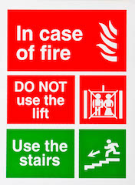 | 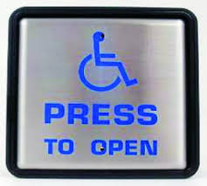 | 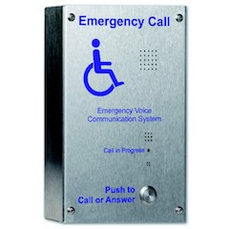
Lift fire safety information | Disabled exit devices serviceable | Voice communication at disabled Refuge Points is serviceable
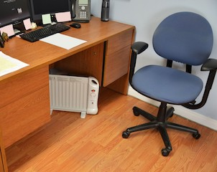 | 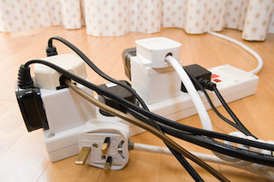 | 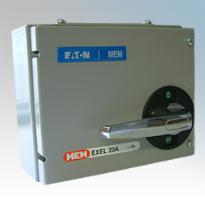
Heater misuse hazard | Electrical overloading hazard | Daily electrical isolation procedures for closing down
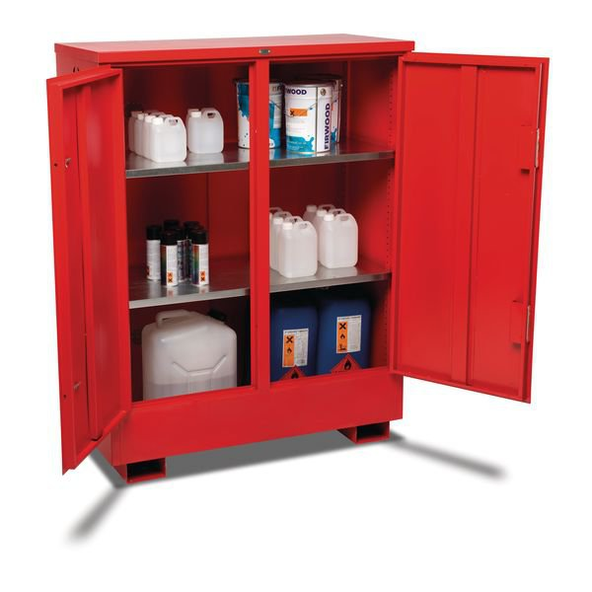 | 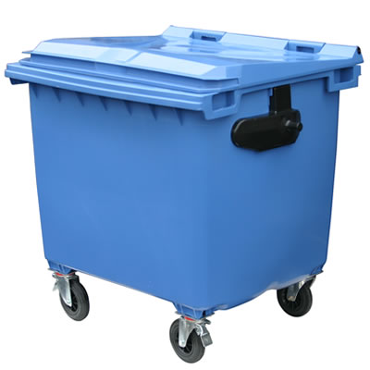 | 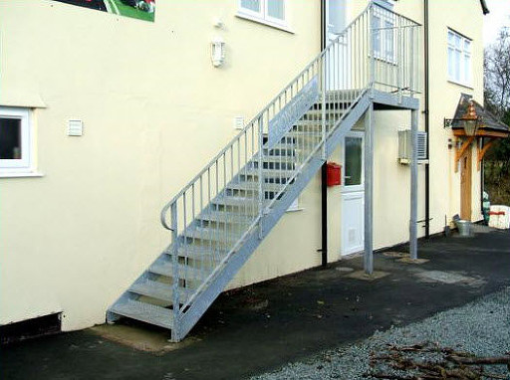
Safe & secure storage of flammable materials & liquids | External waste in secure bins & regular collections to discourage arson & vandalism | Maintenance of external escape routes & stairs (seasonal growth & freezing conditions)

Miscellaneous Tests & Checks Record

Date | Items tested/checked | Remedial action required | Date completed | Name of tester  (print)

Miscellaneous Tests & Checks Record

Date | Items tested/checked | Remedial action required | Date completed | Name of tester  (print)

Section 10. Visits by the Fire & Rescue Service

Routine Inspection Audit – Under the Regulatory Reform (Fire Safety) Order 2005, Local Authority Fire Service Inspectors are required to carry out formal fire safety compliance audits of premises to ensure, amongst many other criteria, that a suitable fire risk assessment has been undertaken and there are appropriate fire safety measures in place to ensure persons who resort to your workplace are not at risk from fire, hazardous materials or processes. They normally give you sufficient prior written notice of the audit, typically one month; and provide you with a detailed list of documents, records and evidence that will be necessary and are to be made available at the audit for scrutiny.

This fire safety logbook is an essential element of the audit requirement and should demonstrate an ‘evidence based’ record of a comprehensive fire safety management culture, providing all the tests, checks, servicing and maintenance schedule entries are made within the relevant sections, (together with other sources of information e.g. certificates of electrical and gas safety checks, contractual maintenance schedules of any fire suppression and ventilation systems etc.) and that the necessary remedial actions have been undertaken by competent persons and in a reasonable time frame. It is advisable to invite the Inspecting Officer to sign this logbook at the Record page overleaf.

Following the audit, the Inspector will provide you with an audit report outcome that indicates a Compliance Level to The Fire Safety Order 2005. You will be informed at the time; and in writing, if your business workplace meets the necessary Compliance Level and no further action will be required. If however there are any issues of non-conformity, not only will you have been made aware of them at the time, but you may also receive an Advisory Letter, or a Formal Notice of Deficiencies identifying the areas that need to be addressed within a reasonable timescale and; depending on the severity of any issues, they may also serve an Alterations, Enforcement or Prohibition Notice.

Non-Routine (no prior notice) Inspection Audit – Following any outbreak of fire at your premises that requires a ‘Post-Fire Investigation’ (or should any concern be raised with regards to your premises’ fire safety measures by another Enforcing Authority or Agency), the Local Authority Fire Service Inspector is empowered to visit your premises without prior warning or notice under the Fire & Rescue Services Act 2004. Any issues of non-conformity will be made apparent as detailed in the above paragraph.

Fire & Rescue Service – Record of Visits

Date | Nature of Visit | Inspector’s signature | Comments

Peninsula Fire Safety Consultants are an established provider of fire safety advice, fire risk assessments, site survey compliance audits, Building Control applications, and an ‘advocacy service’ to liaise on your behalf with Local Authority Fire Services and other Industry Regulators. We have experience in all workplace industries, risk processes and premises that require compliance with the Regulatory Reform (Fire Safety) Order 2005.

We will fully engage with you, whether you are a small business or large organisation, to deliver cost effective fire safety assurance that is tailored to suit your needs, allowing you to focus more on the primary task of running your business profitably and safely.

‘Following a significant fire event, many businesses never entirely recover - losing orders, contracts, key employees, or simply go out of business soon after, resulting in lost jobs and services to the community’. Source: Fire Protection Association & Arson Prevention Bureau

Our operations are based in the South West of the UK and if you need advice on ensuring your workplace is fire safety compliant, or perhaps you require a specific service, please call our office (01822) 841041 alternatively, visit our comprehensive web page Contact Us section at www.peninsulafireconsultants.co.uk for a ‘no obligation’ advisory response.

